KWAZULU-NATAL
PHOENIX/VERULAM/TONGAAT CLUSTER

INFORMATION TECHNOLOGY
Grade 10

Paper 01

FINAL EXAMINATIONS – 2011
PAPER 2

09 November 2011

Duration: 2½ Hours Marks: 180

This paper consists of 6 questions printed on 11 pages (including the cover page)

Instructions :

- Read the instructions carefully before answering any questions.

- Answer all questions in the answer book provided

- Start your answers to each question on a new page

- Write legibly

- Return the question paper with you answer booklet.

SECTION A

Read the introductory information in each of the subsections and then answer the questions accordingly.

QUESTION ONE GENERAL HARDWARE & SOFTWARE

1.1 | Identify the correct answer for each question. Write only the letter of the answer next to the question number for example: 1.11 D.
1.1.1 | Which one of the following is a typical example of a WAN?  A. Users connected via a Bluetooth connection  B. A network in a school  C. Any network linked with fiber optic cable  D. A country-wide network of a bank
1.1.2 | Which one of the following is not associated with obtaining help when using a software package?  A. Macros  B. FAQs  C. Wizards  D. F1 key | (1)
1.1.3 | Which one of the following e-mail options allows you to send a copy of the message so that the recipient’s name is not visible to other recipients of the message?  A. Cc  B. To  C. Bcc  D. Forward | (1)
1.1.4 | Which one of the following terms does not logically belong with the others?  A. HTTPS  B. Amazon.com  C. Hub  D. Shopping cart | (1)
1.1.5 | Which of the following is not associated with green computing?  A. Paperless offices  B. Reusing ink cartridges  C. Using Energy Star compliant hardware  D. Replacing computer equipment on a three-yearly basis | (1)

1.2 | Match the most appropriate terms/concepts in Column B with each of the descriptions in Column A. Write only the question number and the letter of your choice, for example: 2.1 P.
Column A | Column B
1.2.1 The electronic equivalent of ‘junk mail’ sent out in bulk without the recipients requesting it. | A | ADSL
1.2.2 A hardware component manufactured by companies such as Intel, AMD and Motorola. | B | BIOS
1.2.3 A portable wireless Internet connection available in South Africa. | C | CPU
1.2.4 A port commonly used to connect hardware ranging from printers to flash disks. | D | CTS
1.2.5 A device that enables a computer to send and receive information via telephone lines. | E | dpi
1.2.6 An example of a portable digital audio player. | F | eBay
1.2.7 A unit of measurement of resolution associated with both monitors and printers. | G | EULA
1.2.8 A technology that allows voice conversations to take place via a network such as the Internet. | H | GPS
1.2.9 An example of an online auction website. | I | iBurst
1.2.10 A device that can be used to determine your geographical location using satellite technology. | J | iPod
 | K | modem
 | L | ppm
 | M | spam
 | N | USB
 | O | VoIP

 | (10)
 | Total Question 1 (15)
SECTION B

Use the scenario below to answer the QUESTIONS 2 → 6

SCENARIO
Your school in the area in which you live, is hosting a major sports meeting for various schools. You serve on the organising team. You and the team (together with the teachers involved) are expected to:
- give technical advice
- assist in the pre-planning
- manage events on the day
- report on the performance of participants and schools
- determine the expenses for the day and
- other relevant items

QUSTION TWO HARDWARE & SOFTWARE

2.1 | Your school has offered to purchase an additional computer to use on the day of the meeting. Study the advert below and answer the questions that follow :  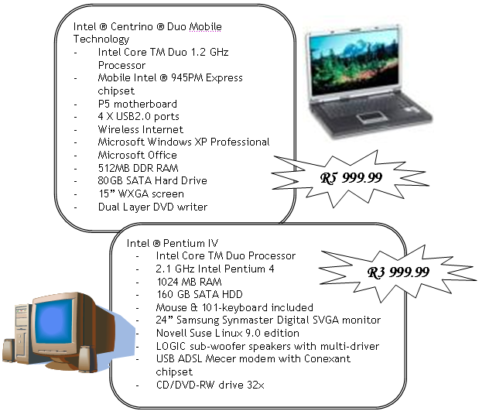

 | 2.1.1 Which of these computers has the faster CPU speed (laptop or desktop)? Specify the speed of this CPU in your answer. | (2)
 | 2.1.2 What is the capacity of the primary memory of the laptop on offer? | (1)
 | 2.1.3 What is the capacity of the secondary memory of the laptop on offer? | (1)
 | 2.1.4 Identify the open source operating system included with one of these computers. | (1)
 | 2.1.5 The two types of Internet connection that are listed in the adverts are wireless and ADSL. Give TWO reasons why it might be preferable to use wireless as opposed to ADSL on the day of the meeting. | (2)
 | - The laptop includes a DVD writer.  - Will this device be able to read and write CDs? Briefly motivate your answer.  - What does CD stand for?  - What does DVD stand for? | (1)  (1)  (1) | (10)
2.2 | The computer you chose has a wireless mouse. Name ONE advantage and ONE disadvantage of using a wireless mouse on the day of the meeting. |  | (2)
2.3 | Give ONE advantage and ONE disadvantage of using the laptop as opposed to the desktop computer on the day of the meeting. |  | (2)
2.4 | You would like to have a digital camera to be able to record the events of the day. Name TWO specifications that you ought to consider when choosing a digital camera, besides the cost and warranty. |  | (2)
2.5 | A printer will be required to print results that will be read our by on the Public Address system. You have a choice between a inkjet printer and a LaserJet printer. Which one will you suggest and why? |  | (2)
2.6 | If one character uses one byte of memory, approximately how many characters could be stored on the RAM on the laptop? Show all your working |  | (2)
 | Total Question 2 |  | [20]

QUESTION THREE SOCIAL & ETHICAL ISSUES

3.1 | Before the event, all previous records as well as the details for all participants need to be captured and stored in a database. Because of the large amount of data needed, this will require data capturers to sit for many hours at a computer. One therefore needs to think about “ergonomics”.
 | 3.1.1 Name TWO health issues associated with prolonged use of computers and suggest a solution in each case. | (4)
 | - Suggest TWO possible methods of entering the data that does not require keying (typing) it in. | (2)
 | 3.1.3 Explain what the term ergonomics means. | (2) | (8)
3.2 | A student that is assisting has brought in some pictures on her flash disk. You are concerned that the files may contain a virus.  List 2 steps that you would follow in order to ensure that the data is safe to use. |  | (2)
3.3 | Another member of the team has indicated that he has software that can be used to generate fancy graphics for the design of the athletics program.  Critically discuss the reasons for not being able to use this software at school. |  | (2)
 |  |  | (8)
 | Total Question 3 |  | [20]

QUESTION FOUR DATA COMMUNICATIONS AND NETWORKS

4.1 | The school wishes to make use of their Internet site in terms of promoting and facilitating the organisation of the athletics meeting. They currently use Telkom as their ISP and their website is located at:  http://www.wonderfulhighschool.org.za.
 | 4.1.1 Briefly describe what the function of an ISP is. | (2)
 | 4.1.2 The .org part is one of several top-level domain names. What does the .org in an URL generally indicate? | (2)
 | 4.1.3 Each of the organisers needs to be assigned an e-mail address.  Would it be better to use their current ISP to set up e-mail addresses or to rather make use of a Web-based e-mail service such as Webmail? Give TWO reasons to support your answer. | (2)
 | 4.1.4 A web page for the meeting has been created. List THREE factors that could influence web surfers to return to the website besides the actual content itself. | (3)
 | - As part of a publicity drive you have been encouraged to set up a blog on the website. Explain what is meant by the term blog. | (2)
 | 4.1.6 Briefly explain what a domain name is in terms of the Internet and list the domain name of this school. | (2) | (13)
4.2 | One of the members on the team has heard of the term TCP/IP. He is not sure what this means
 | 4.2.1 Write down what the following abbreviations stand for and give a brief explanation of the function/purpose of each.  - TCP  - IP |  | (3)
4.3 | While working on the project, a member of the team stated that he would like to follow a career as a network administrator. List 4 duties of a network administrator. |  | (4)
4.4 | Messages need to be sent to the various schools.  List and discuss TWO ways in which short messages could be sent to the various schools. |  | (4)
4.5 | Your teacher has reminded you to be aware of “netiquette” when using the Internet during the course of your preparation for the event.  Explain what is meant by the term netiquette. |  | (1)
 | Total Question 4 |  | [25]

QUESTION FIVE INTEGRATED SCENARIO

5.1 | The organizing team has decided to keep track of the number of athletes attending, together with lunch costs that may be incurred. Part of the spreadsheet used is represented below :  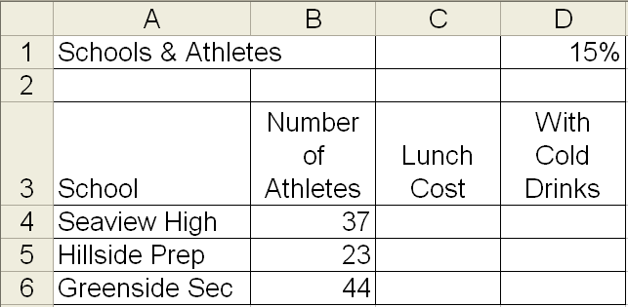
 | 5.1.1 Write down the formula that would be used in cell E4 to determine the total costs of lunch for Seaview High if the lunch per person costs R 30.  5.1.2 In the event of the school providing the athletes with  cold drinks, there will be an estimated 15% increase  in the lunch costs. Insert a formula for cell F4 that will  determine the projected cost if cold drinks are  included in the lunch. Remember that this formula  will be filled for the rest of the schools.  5.1.3 Write down a function that would be used to calculate  the total cost of lunch for all schools. Assume that  data has been filled up to row 35. | (2)  (3)  (2) | (7)
5.2 | A database contains a number of features such as tables, queries, forms and reports. Your team has been tasked to set up a database that stores certain details of all schools that will be participating. The main table called SCHOOLS in the database must contain the essential information about the schools that have entered.
 | 5.2.1 Choose THREE fields that you think are important for SCHOOLS table. Give each of them a suitable fieldname. Suggest a suitable data type for each field. Each field should be an example of different types of data. Suggest a suitable size for each field, if applicable  Example :  FIELDNAME TYPE SIZE  SchoolName Text 25  CoEd Yes/No Not applicable  NB : Do not use the given examples!!! | (3)
 | 5.2.2 When you create the SCHOOLS table, the  application suggests that you create or let it create a  primary key.  5.2.2.1 Explain the purpose of a primary key.  5.2.2.2 Suggest a suitable primary key for the SCHOOLS  table mentioned above. | (1)  (1)
 | 5.2.3 Give one reason for using a form. | (1)
 | 5.2.4 When creating a report, various features may be  applied. Suggest TWO features that your team may  use when creating a report for the principal. | (2)
 | 5.2.5 Apart from the SCHOOLS table, the manager will use queries during the course of his work. Explain what a query is and give an example of a query that the manager may use in the running of the centre | (2) | (10)
5.3 | One of the store owners has received flash disk with various files. He would like to know what type of file each one is. Indicate the type of file for each of the following.  5.3.1 Abc.jpg  5.3.2 Abc.pdf  5.3.3 Abc.mp3 |  | (3)
 | Total Question 5 |  | [20]

QUESTION SIX PROGRAMMING AND SOFTWARE DEVELOPMENT

Mr Gregory has asked you to design some software that he can use to calculate an incentive bonus that he gives to his employees who will be working in one of the tuck-shops during the sports events. He gave you the following requirements:

If their total sales made for the event is less than R2 000.00, they earn a 0.5% incentive bonus of their total sales made.

If their total sales made for the event is greater than or equal to R2 000.00 but less than
R 5 000.00 they earn a 0.55% bonus of their total sales made.

If the total sales made for the event is R 5 000.00 or greater they earn a 0.65% bonus of their total sales made.
Study the incomplete program that has been designed with the above mentioned specifications in mind and answer the questions that are based on it.

